PROGRAM TITLE
ASSET MANAGEMENT

PROCESS TITLE
Trucking Repairs and Maintenance

- SCOPE

This policies and procedures manual establishes policies, systems, procedures and controls on the repairs and maintenance of company vehicles. All duties and responsibilities stated in this manual are not exclusive to the personnel’s designated responsibilities in this process title.

- OBJECTIVES

- To provide clear guidelines in the overall repairs and maintenance of company vehicles and trucks.
- To ensure that proper documentation is established to monitor the procedures and progress in the repairs and maintenance of company vehicles.
- To clearly define the duties and responsibilities of all personnel involved in this process title.

- PERSONNEL INVOLVED

  - President and other signatories

    - Recommends the following documents for approval:
- Bill of Materials (BOM)
- BOM Summary
- Motorpool Repairs and Maintenance Schedule Log (MRMSL)
    - Approves the following documents:
- BOM
- BOM Summary
- MRMSL

  - Appropriate Approving Officer

    - Approves the Trucking Repairs and Maintenance Form (TRMF).
    - Signs the Compliance Report upon completion of repairs and maintenance of company vehicles.
  - Chief Mechanic

    - Monitors and updates the details in the Preventive Maintenance System (PMS) Schedule Log.
    - Prepares the following documents:
- TRMF
- Quality Control Inspection Form (QCIF)
- Rectification Notice (RN)
- Completion Report (CR)

    - Verifies the details indicated in the Motorpool Truck Diagnostic Evaluation (MTDE).
    - Checks the condition of the ongoing trucking repairs and maintenance.
    - Provides feedback to Purchasing Department and Warehouse Department for problems encountered with procured and issued materials and spare parts.
    - Submits Incident Report to Human Resource Department for corrective actions regarding incorrect procedures applied on trucking repairs and maintenance by Motorpool staff.

  - Technician

    - Receives the Job Assignment from the Motorpool Supervisor.
    - Conducts diagnostic evaluation on the company vehicle.
    - Prepares the following documents:
- MTDE
- Motorpool Repairs and Maintenance Schedule Log (MRMSL)
- BOM
- BOM Summary
- Materials and Services Procurement Requisition Form (MSPRF)
- Materials Requisition Slip (MRS)

    - Receives the duly approved MRMSL, BOM and BOMS, and updates the Motorpool Repairs and Maintenance Problem Reporting (MRMPR) System.
    - Supervises the execution of trucking repairs and maintenance.

  - Motorpool Supervisor

    - Verifies the following documents:
- TRMRF
- BOM
- MRMSL

    - Provides Job Assignments to Technician for the execution of repairs and maintenance.

  - Truck Driver

    - Prepares the following documents:
- TRMRF
- Motorpool Immediate Action Repair (MIAR)

    - Forwards the TRMRF to the Motorpool Supervisor for verification.

- KEY TERMS

  - Preventive Maintenance – Maintenance carried out at predetermined intervals or according to prescribed criteria and intended to reduce the probability of failure or malfunctioning of trucks.

  - Corrective Maintenance – Maintenance performed to identify, isolate, and rectify a fault so that the trucks can be restored to good operational condition.

  - Tool box meeting – An informal safety meeting that focuses on safety topics related to the specific job, such as workplace hazards and safe work practices. Meetings are normally short in duration and are generally conducted at the job site prior to the commencement of a job or work shift.

- POLICIES

  - General Policies

    - Only authorized persons are allowed inside the Motorpool Area. Moreover, only properly trained personnel shall be allowed to use tools and equipment.
    - All major and minor repairs are to be reported to the Chief Mechanic.
    - The type of the repair – immediate or normal – must be duly indicated in the Trucking Repairs and Maintenance Form (TRMF).
    - A “tool box meeting” must be conducted every day before the start of repairs and maintenance work. The meeting should be properly documented and minutes of the meeting shall be prepared and filed. The following topics should be included in the meeting:
- Progress of the work list items
- Items to be carried out during the day
- Modifications to the work specification

    - An emergency tool box or kit must be always available which must contain the following items, at a minimum:
- Jack
- Spare tire
- Wrench
- Rain poncho
- Gloves
- Flashlight with working batteries
- Small cut of 2x6 wood to secure jack
- Triangular Reflectors
- Wheel wedges

  - Preventive Maintenance

    - Preventive maintenance is performed daily and at prescribed intervals. Preventive maintenance is monitored using the PMS Schedule Log.
    - Truck drivers must perform a pre-trip inspection prior to the start of their shift. It is the truck driver’s responsibility to make notations on the pre-trip inspection form of any defects found during pre-trip inspection, while driving throughout the day or during the post-trip inspection at the end of the day. Upon completion of the pre-trip inspection form, the form is turned in to the Engineering/Trucking Department for monitoring.
    - Daily maintenance shall, at a minimum, include the following:
- Fuel and fluid level checks (engine oil, transmission oil, engine coolant and power steering fluid)
- Tires are checked for flats
- Wheel nuts are observed for loose wheels
- Exterior and interior lights are checked
- Interior of the vehicles are cleaned and checked for any damage

    - Company vehicles and trucks which are out of service, including any backup vehicles, will be looked at once a week to detect any leaks (fluids), flat tires, or any other deterioration. The backup vehicles will be started and allowed to run long enough to warm the engine and transmission fluids once each week. Any defects detected will be duly indicated in the individual Maintenance Card stored per truck.

  - Corrective Maintenance

    - If there is an on-the-road emergency with the trucks, the truck driver will immediately advice the Trucking Supervisor for assistance. However, if the Trucking Supervisor is unavailable, the next higher personnel in authority (i.e. Trucking Manager) must be contacted.
    - Corrective maintenance shall be allowed where the need is urgently indispensable to prevent immediate danger to, or loss of life and/or property, or to avoid damage to the public service, as certified by the responsible driver and approved by the head of office concerned.
    - In emergency situations, replacement of non-repairable truck parts are allowed subject to approval of the President.

  - Documentation

    - Business forms shall be used, issued and/or printed sequentially.
    - Truck records shall be kept on each individual vehicle. Records contain all maintenance tasks performed, vehicle miles and vehicle maintenance cost.
    - All records shall be neatly and legibly kept in ink to prevent alteration of records.
    - Business forms shall be duly filled-out and signed by designated signatories. Any details/signatories which are not applicable must be duly indicated with “N/A”.
    - If designated signatory is unavailable, printed evidence of consent (i.e. text, emails, etc.) shall be attached to the business form which should be post-approved by the designated signatory.
    - Alterations, if any, shall be duly countersigned.
    - Bill of Materials shall be recommended for approval and approved by the following:

Amount of Repairs | Recommended for Approval by: | Approved by:
P10,000 and below | N/A | Department Manager
P10,001 to P50,000 | Department Manager | Vice President (VP)
Over P50,000 | Vice President | Senior VP / President

  - Handling of Tools and Equipment

    - An authorized staff shall be appointed in monitoring the issued materials, tools and equipment and spare parts in the Motorpool Area.
    - While the repairs and maintenance is in-progress, any unused materials should be properly arranged/neatly stacked in the designated areas in the Motorpool Area and must be labeled to ease identification.
    - All tools and equipment shall be handled with care. Any plugged equipment should be unplugged after its use.
    - For new equipment, a run-through (pilot test) shall be made in the presence of the Motorpool Supervisor and all other motorpool personnel expected to use the equipment. The manual of the equipment shall be considered.
    - No tools or equipment shall be taken out of the Motorpool Area without the permission of the Motorpool Supervisor.
    - Any sign of pilferage, theft, robbery, loss or untoward incidents shall be reported immediately to the Motorpool Supervisor.
    - All unused materials, and tools and machineries used in the conduct of the repair shall be returned immediately to the Warehouse/Tool room. The return of the unused materials and supplies shall be returned with duly approved Materials and Supplies Return Slip (MSRS). The tools and machineries shall be returned to the Tool Room together with the previously signed copy of the Accountability Form.

  - Safety Management and Cleanliness

    - The Motorpool Area shall always be kept clean and tidy.
    - Equipment not in use should be stored properly in the warehouse or appropriate designated areas in the Motorpool Area.
    - After completion and turnover of repaired truck, a final cleaning of the Motorpool Area where the repair was conducted must be carried out.
    - Eating and drinking are only allowed in designated areas inside the Motorpool Area.
    - Drinking alcohol and smoking are strictly prohibited inside the Motorpool Area.
    - Working while under the influence of intoxicating agents (e.g. alcoholic liquor or certain drugs) is strictly prohibited.
    - When inside the Motorpool Area where repairs and maintenance is taking place, personnel must wear proper personal protective equipment (i.e. hard hat, safety shoes, safety gloves, safety goggles, face mask, welding shield, etc.).
    - Workers must be instructed in the correct use of fire-fighting equipment.
    - Where necessary suitable and sufficient fire-fighting equipment and fire detection and alarm systems must be installed.
    - Appropriate precautions must be taken when using hot work in the vicinity of flammable materials. Where possible any combustible items should be removed before the hot works commence.

  - Incident reports

    - An Incident Report must be prepared for problems encountered during repairs such as but not limited to incorrect procedures applied and incorrect materials and spare parts used.
    - When incorrect procedures are applied by the Motorpool personnel, an Incident Report is prepared by the Chief Mechanic to be forwarded to the HR Department for appropriate sanctions (refer to Human Resource’s Code of Conduct).
    - When incorrect procedures were applied by the Service Provider/Contractor, an Incident Report is prepared by the Chief Mechanic to be forwarded to the Operations Department. Moreover, a Rectification Notice is prepared and to be acknowledged by the Service Provider/Contractor indicating the details of the incorrect procedures applied and appropriate course of action. Afterwards, rework and rectification procedures are to be conducted.

    - When truck is not running in good condition due to problem with the materials and spare parts used, an Incident Report is prepared and a feedback is forwarded to the Purchasing Department and Warehousing Department. A new set of requisition is then prepared for the requisition of materials and spare parts for rectification of work done.

- PROCEDURES

Trucking Maintenance Procedures

Step No. | Activity | Personnel  Involved | Business  Forms
1 | For periodic maintenance, Chief Mechanic checks PMS Schedule Log and prepares Truck Repairs and Maintenance Form (TRMF).  For corrective maintenance, Truck Driver prepares TRMF and indicates the problems encountered. Forwards the same to the Chief Mechanic. | Chief Mechanic; Truck Driver | Duly filled-out TRMF
2 | Forwards the TRMF to the Motorpool Supervisor for verification. | Chief Mechanic | Duly filled-out TRMF
3 | Verifies TRMF. | Motorpool Supervisor | Duly verified TRMF
4 | Receives verified TRMF and forwards the same to the Appropriate Approving Officer for approval. | Chief Mechanic | Duly verified TRMF
5 | Approves the TRMF. | Appropriate Approving Officer | Duly approved TRMF
6 | Receives duly approved TRMF and provide Job Assignment to Technician. | Motorpool Supervisor | Job Assignment
7 | Receives Job Assignment and conduct diagnostic evaluation on truck. | Technician
8 | Fills out Motorpool Truck Diagnostic Evaluation (MTDE). | Technician | MTDE
9 | Forwards the MTDE Chief Mechanic for verification. | Technician | MTDE
10 | Verifies the MTDE and updates the PMS Schedule Log. | Chief Mechanic | MTDE
11 | Receives duly verified MTDE and prepares Motorpool Repairs and Maintenance Schedule Log (MRMSL). | Technician | Duly filled-out MRMSL
12 | Prepares Bill of Materials (BOM). | Technician | Duly filled-out BOM
13 | Forwards MRMSL and BOM to the Motorpool Supervisor for verification. | Technician | Duly filled-out MRMSL and BOM
14 | Verifies the MRMSL and BOM. | Motorpool Supervisor | Duly verified MRMSL and BOM
15 | Receives duly verified MRMSL and BOM. | Technician | Duly verified MRMSL and BOM
16 | Forwards duly verified MRMSL and BOM to appropriate authorized signatory for approval of MRMSL and for recommendation for approval of the BOM. | Technician | Duly verified MRMSL and BOM
17 | Signs the “Recommended for approval” of the BOM and approves the MRMSL.  For BOM which needs to be approved by the President, a BOM Summary is prepared for approval by the President. | Refer to section V.D.7, page 5 | Duly approved MRMSL and signed BOM; BOM Summary
18 | Forwards BOM for approval, supported with duly approved MRMSL. | Technician | Duly approved MRMSL and signed BOM; BOM Summary
19 | Approves BOM. | Refer to section V.D.7, page 5 | Duly approved BOM and MRMSL
20 | Updates Motorpool Repairs and Maintenance Problem Reporting (MRMPR). |  | MRMPR
21 | Checks the availability of the Motorpool to cater incoming truck repairs.  If Motorpool is not available, prepare Materials/Services Procurement Requisition Form (MSPRF) and forwards to Purchasing Department for Service Contracting Process. | Technician | MSPRF
22 | Prepares Materials Requisition Slip (MRS) and forwards to Warehouse Department for issuance of materials and spare parts. | Technician | MRS
23 | Execute trucking repairs and maintenance.  Regularly updates MRMSL for repairs and maintenance work status. | Technician | MRMSL
24 | Check condition of ongoing trucking repairs and maintenance and fills out Quality Control Inspection Form (QCIF).  When inspection results show that truck is not in good condition, refer to section V.G.1, V.G.2 and V.A.3, page 6. | Chief Mechanic | QCIF; Rectification Notice (RN); Incident Report
25 | Prepare Compliance Report in two (2) copies. | Chief Mechanic | Compliance Report
26 | Files one copy of Compliance Report, forwards one copy to Motorpool or Service Provider. | Chief Mechanic | Compliance Report
- FLOWCHARTS

  - Trucking Repairs and Maintenance

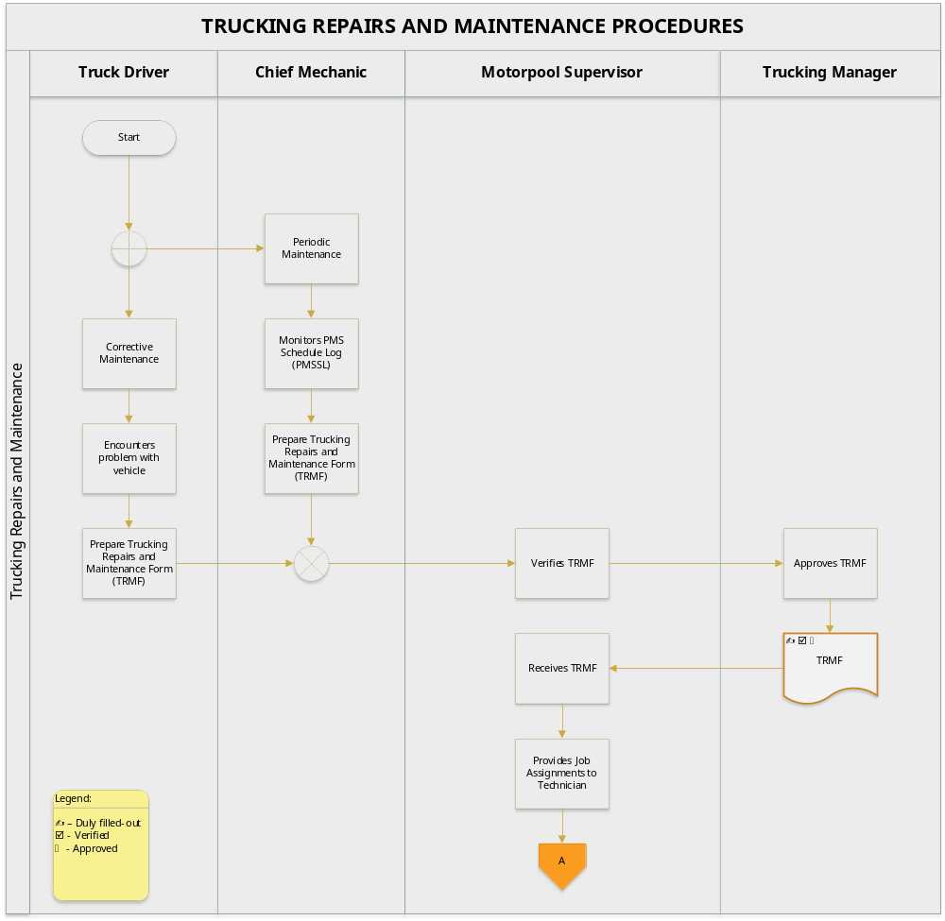

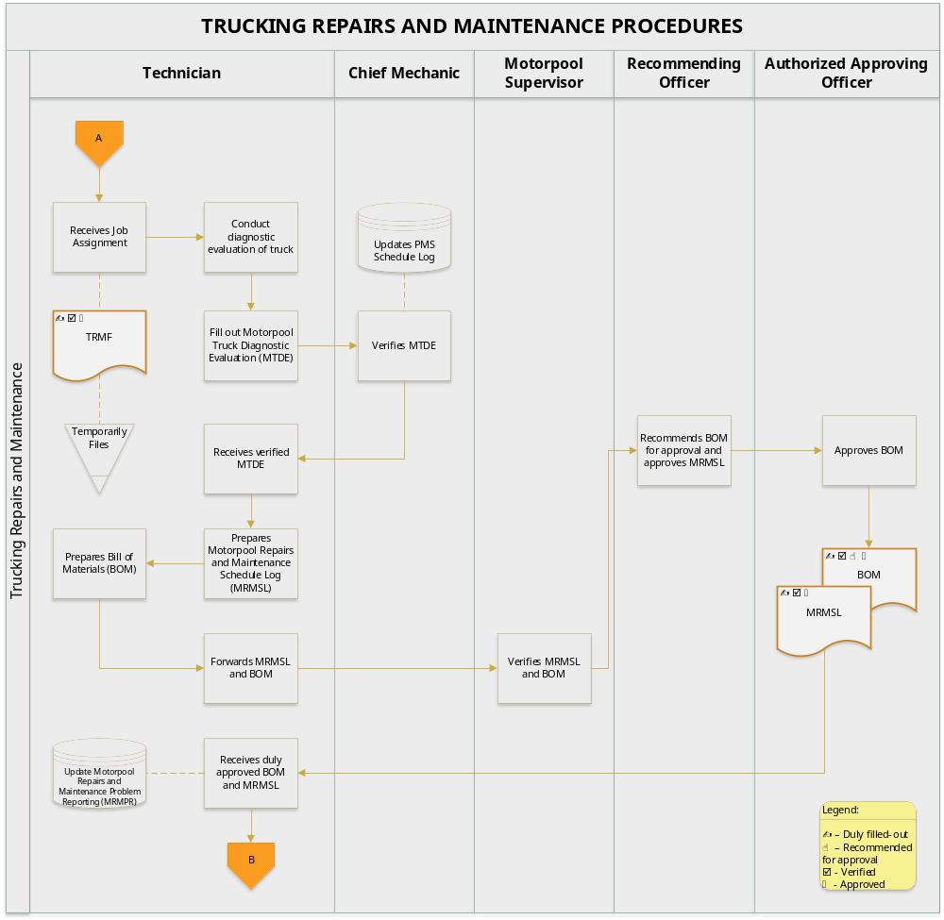

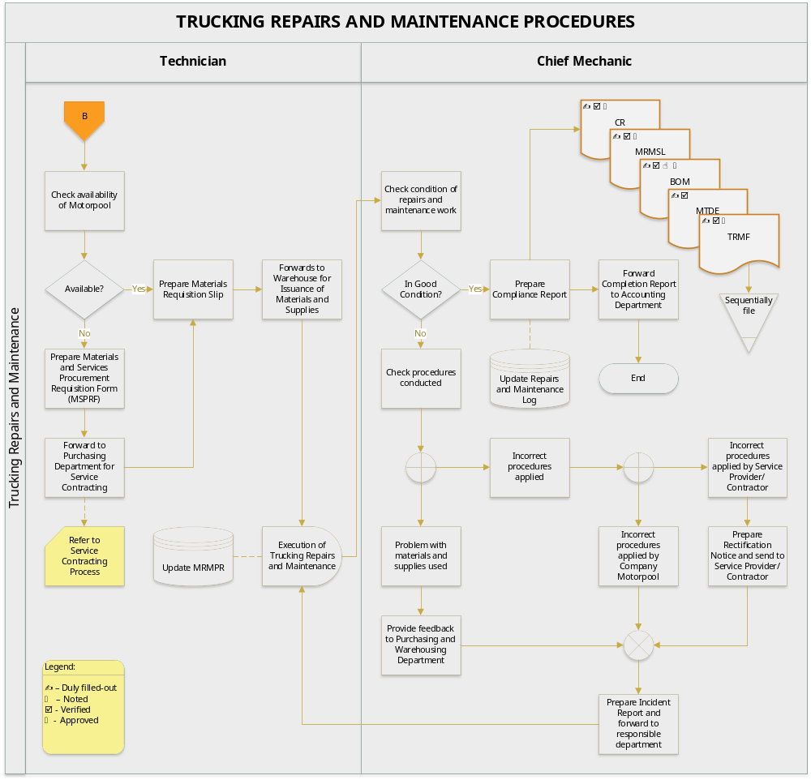
- BUSINESS FORMS

  - Trucking Repairs and Maintenance Form (TRMF)

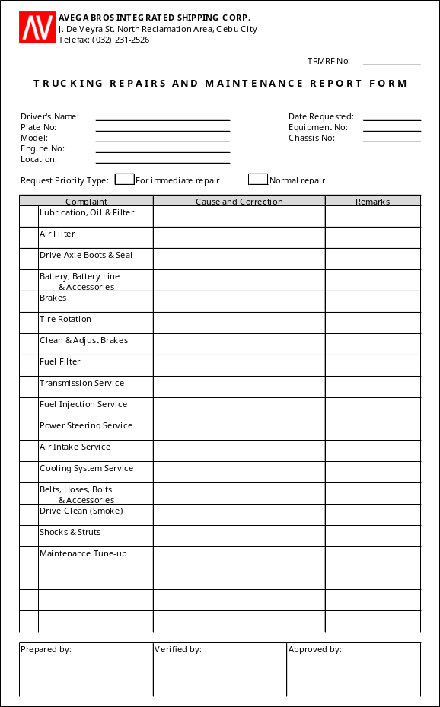

No. of Copies/color - 1 (white)
Explanation - this is prepared to document request for repair of trucks and company vehicles
Prepared by - Truck Driver / Chief Mechanic
Verified by - Motorpool Supervisor
Approved by - Appropriate Approving Officer
Distribution - Motorpool (attached to BOM)

  - PMS Schedule Log

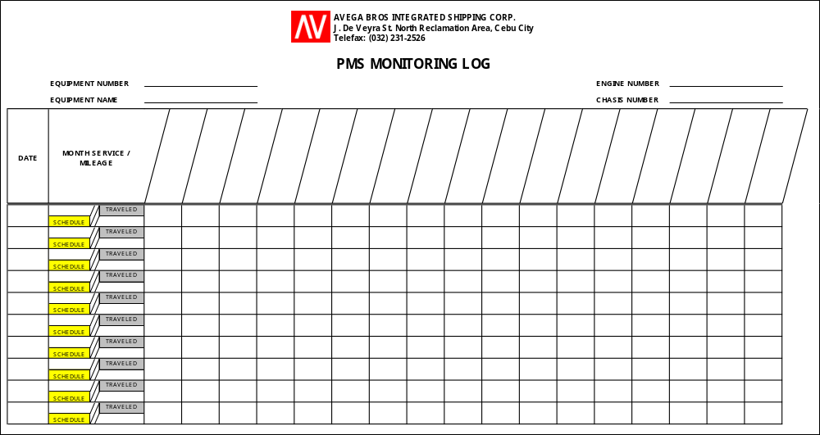

Explanation - this is used to monitor the preventive maintenance schedules of company vehicles
In-charge - Chief Mechanic

  - Motorpool Trucking Diagnostic Evaluation

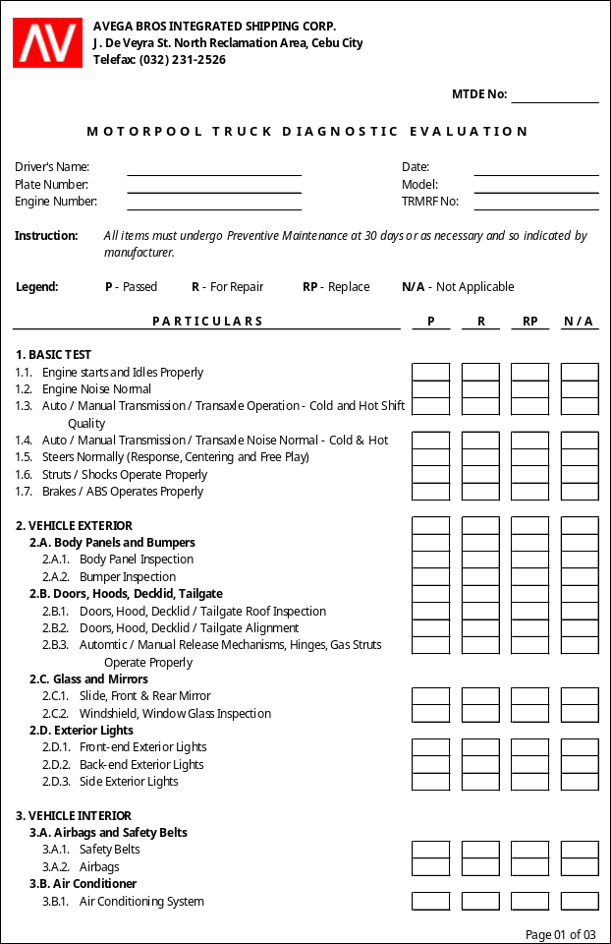

MTDE - Page 01 of 03

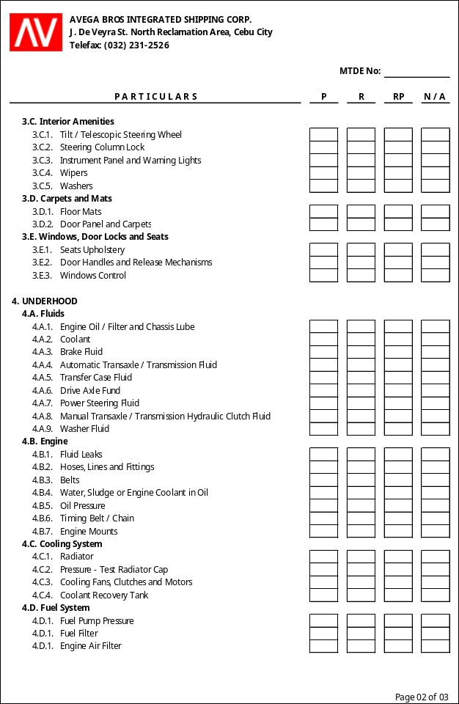

MTDE - Page 02 of 03

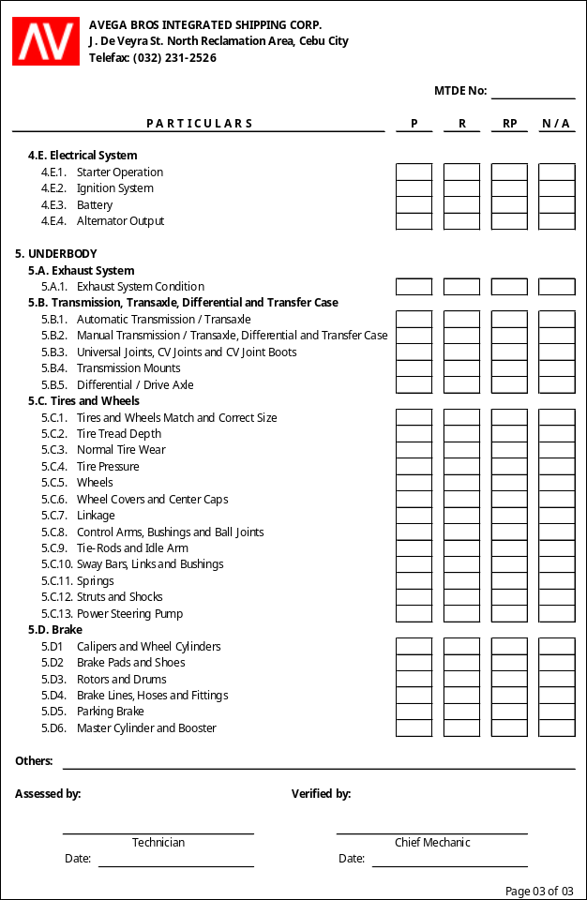

MTDE - Page 03 of 03

No. of Copies/color - 1 (white)
Explanation - this is prepared every time an assessment is conducted in the truck. For periodic maintenance, assessments are to be conducted based on the PMS Guide (see Annex A)
Assessed by - Technician
Verified by - Chief Mechanic
Distribution - Motorpool (attached to the BOM)

  - Motorpool Repairs and Maintenance Schedule Log

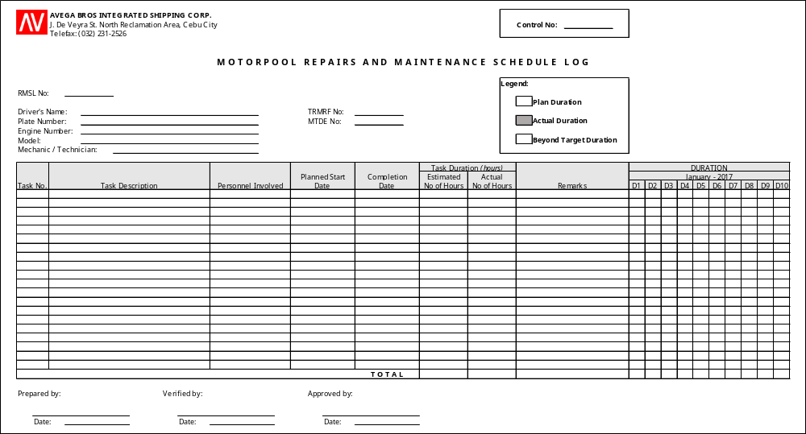

No. of Copies/color - 1 (white)
Explanation - this is prepared to document the work to be done and to summarize the details of expenses indicated in the BOM. This is presented to the President for approval of the BOM and the DDS
Prepared by - Technician
Verified by - Motorpool Supervisor
Approved by - refer to section V.D.7, page 5
Distribution - Motorpool (attached to the Compliance Report, temporarily filed until completion of repairs and maintenance work)

  - Bill of Materials (BOM)

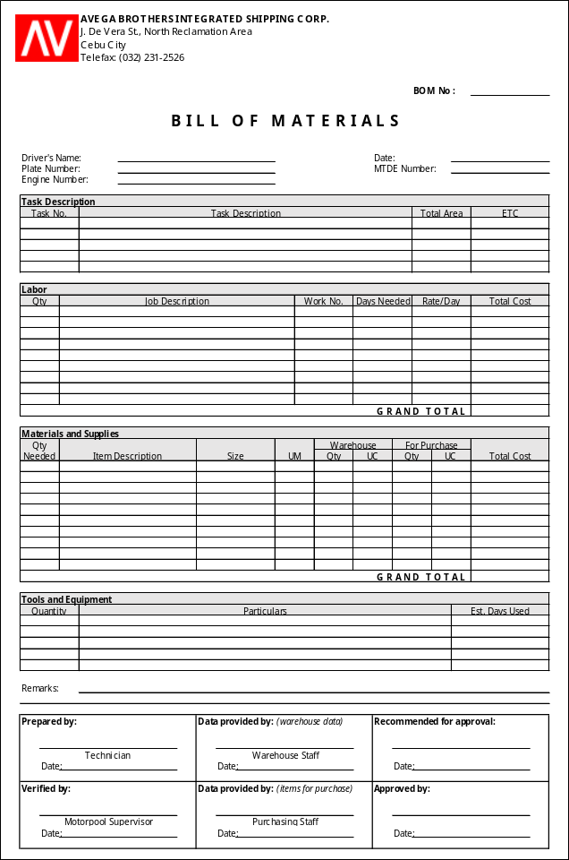

No. of Copies/color - 1
Explanation - this is prepared to indicate the materials, service and equipment needed for the trucking repairs and maintenance
Prepared by - Technician
Verified by - Motorpool Supervisor
Data provided by - Warehouse Staff (warehouse data)
Purchasing Staff (canvassed data)
Recommended for approval - Service Provider/Contractor
Distribution - Motorpool (filed chronologically together with CR, TRMRF, MRMSL and MTDE)

  - BOM Summary

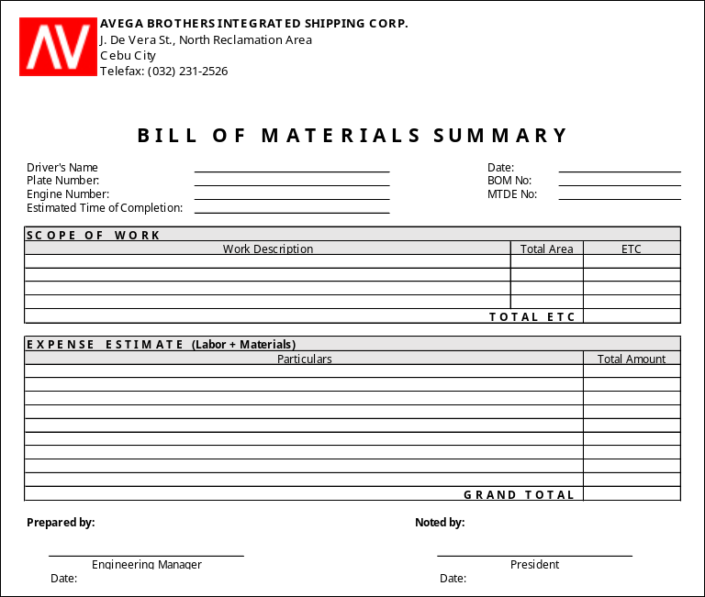

No. of Copies/color - 1
Explanation - this is prepared to document the work to be done and to summarize the details of expenses indicated in the BOM. This is presented to the President for approval together with the BOM and the MRMSL
Prepared by - Appropriate Approving Officer
Noted by - President
Distribution - Motorpool (temporarily filed until completion of repairs and maintenance work)

  - Motorpool Repairs and Maintenance Problem Reporting

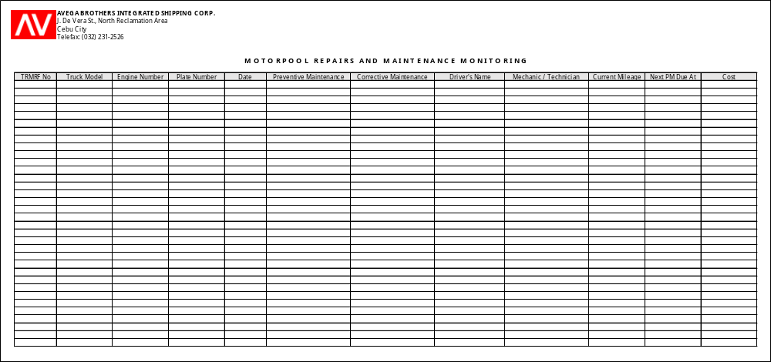

No. of Copies/color - 1
Explanation - this is used to log all repairs and maintenance on company vehicles

  - Quality Control Inspection Form (QCIF)

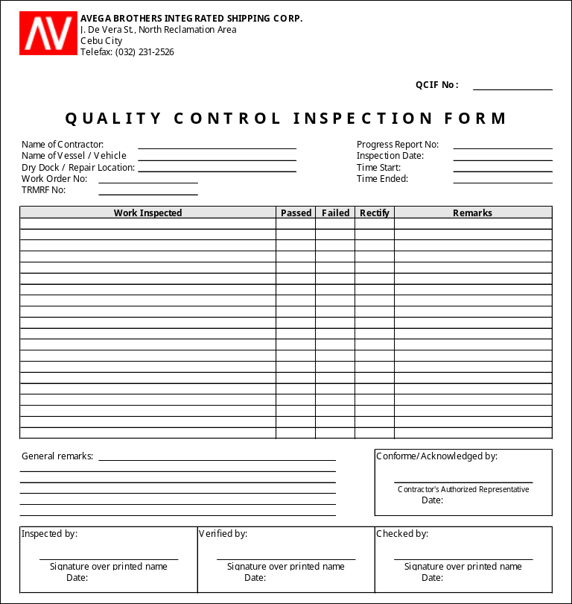

No. of Copies/color - 2
Explanation - this is prepared upon inspection of repairs and maintenance done on company vehicles
Distribution - QCIF 1 - Motorpool (attached to the Compliance Report together with the MRMSL, BOM, MTDE and TRMF)
QCIF 2 - Service Provider/Contractor (if not applicable, both copies are attached to the Compliance Report)

  - Compliance Report

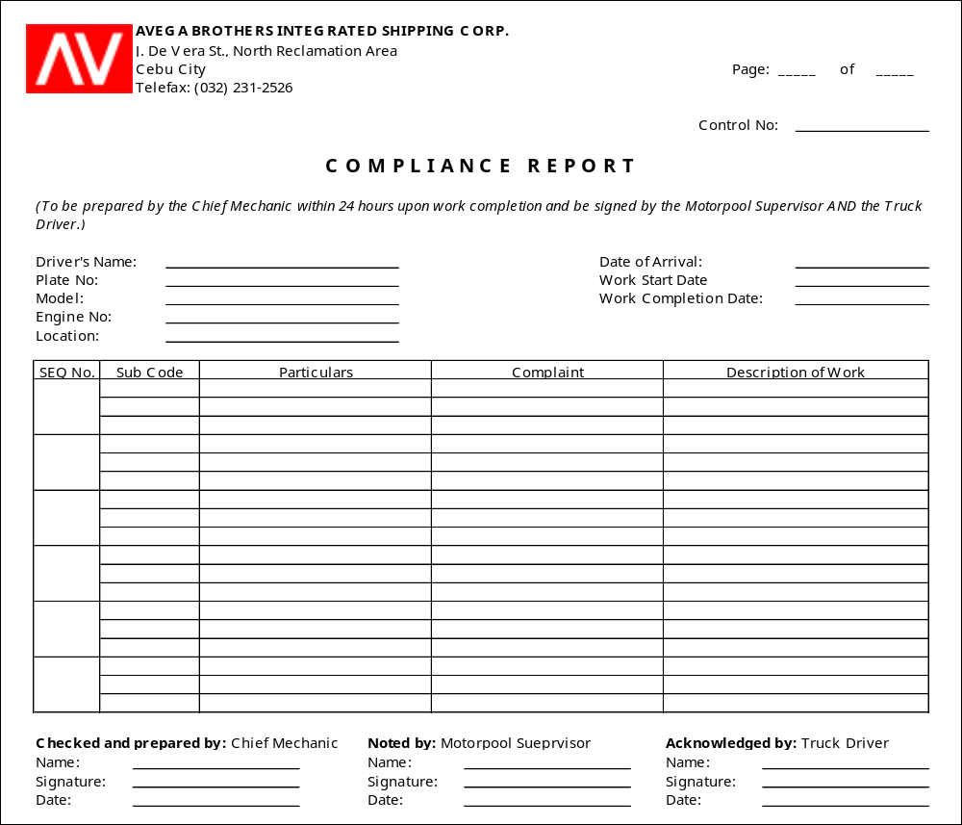

No. of Copies/color - 2
Explanation - this is prepared to certify the 100% completion of the work done by the Service Provider/Contractor or the Motorpool Personnel
Checked and prepared by - Chief Mechanic
Noted by - Motorpool Supervisor
Acknowledged by - Truck Driver
Distribution - CR 1 - Truck Driver’s copy
CR 2 - Motorpool or Service Provider/Contractor

  - Rectification Notice

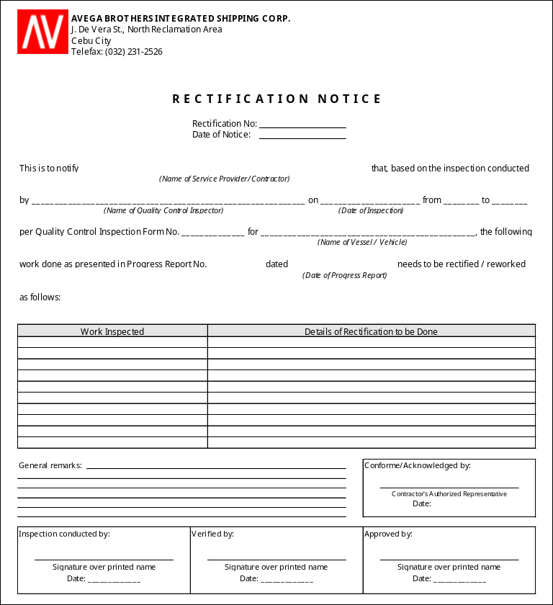

No. of Copies/color - 2
Explanation - this is to document details of rectification to be conducted on company vehicle after inspection
Inspection conducted by - Chief Mechanic
Verified by - Motorpool Supervisor
Approved by - Appropriate Approving Officer
Acknowledged by - Service Provider/Contractor
Distribution - RN 1 - Accounting Staff (attached to the Check Voucher together with the QCIF, Progress Report and Statement of Account)
RN 2 - Service Provider/Contractor
  - Daily Vehicle Condition Report (DVCR)

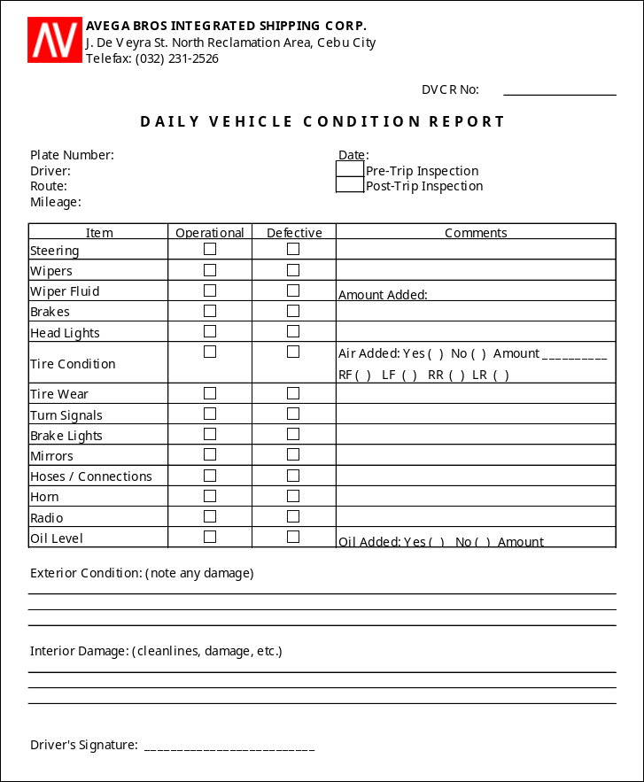

No. of Copies/color - 2
Explanation - this is to document details of pre-trip and post-trip inspection conducted on company vehicle
Signature - Truck Driver assigned on truck
Distribution - DVCR 1 - Truck (kept in the Truck’s file folder)
DVCR 2 - Motorpool (filed per truck)
  - Monitoring Card

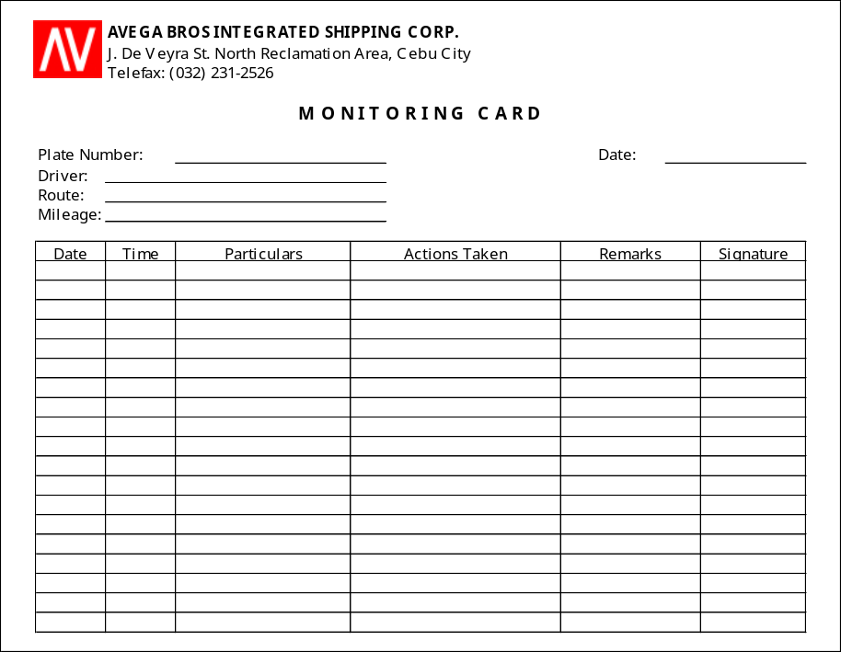

No. of Copies/color - 2
Explanation - this is to document details of repairs and maintenance conducted on truck
Signature - Truck Driver assigned on truck
Distribution - Truck (kept in the Truck’s file folder)

- EFFECTIVITY

This Policies and Procedures Manual shall take effect upon approval and shall supersede any memorandum/SOP inconsistent with this Policies and Procedures Manual. Any changes to the manual shall comply with the policies and procedures indicated in the process title of “Amendment of Manual”.

ANNEX

ANNEX A
PMS Guide

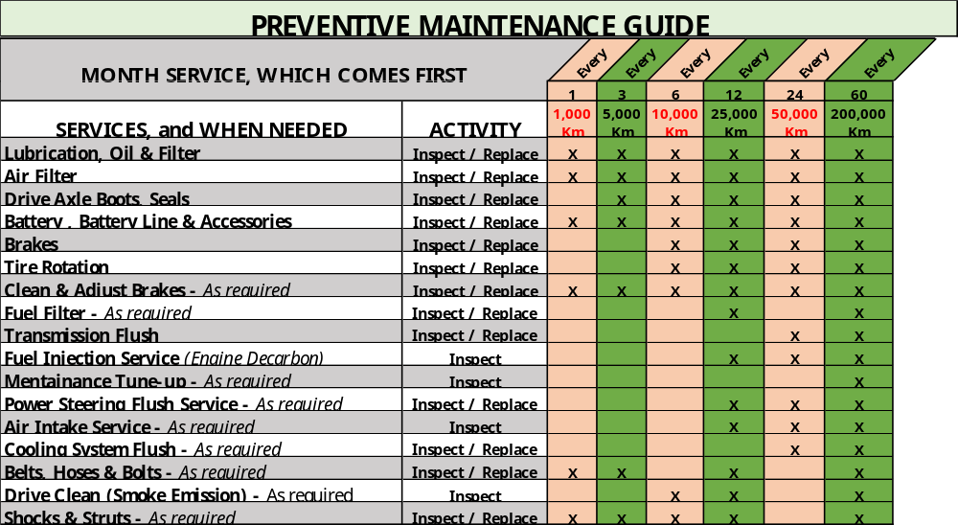

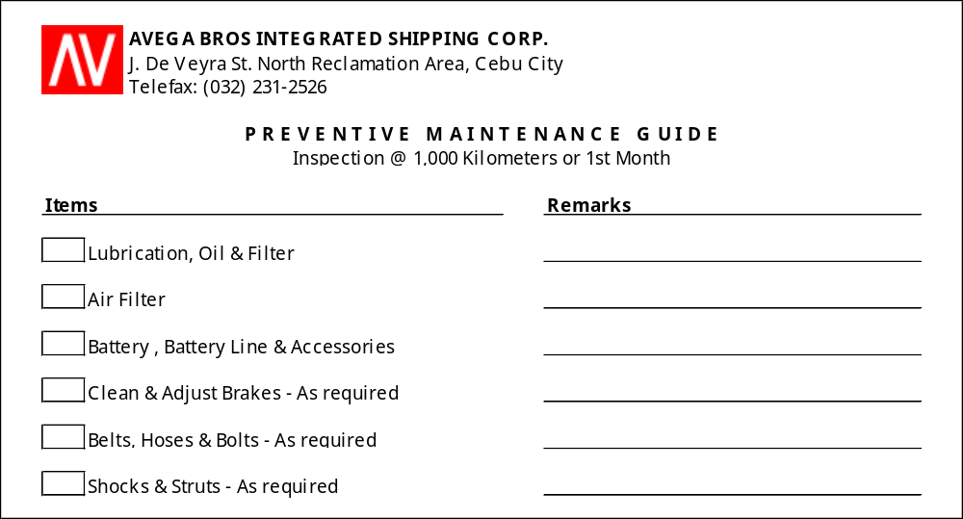

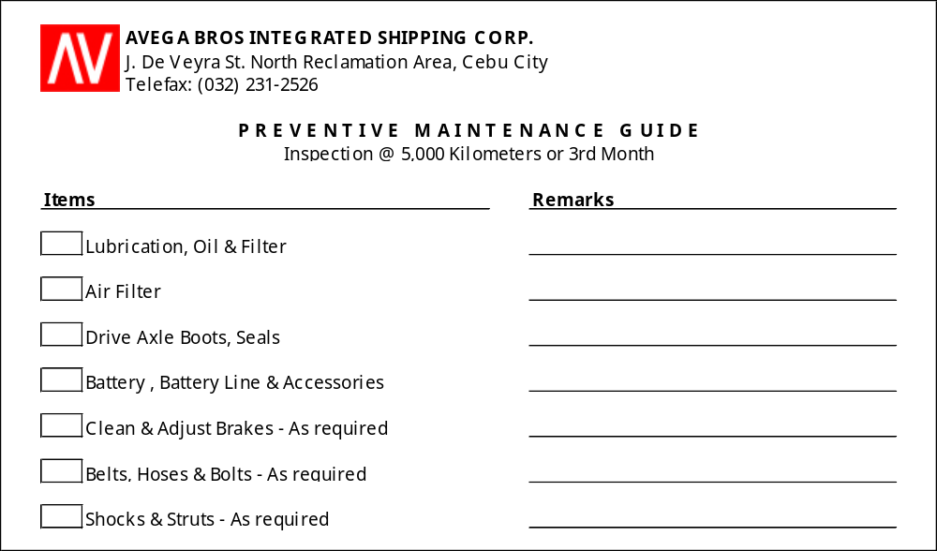

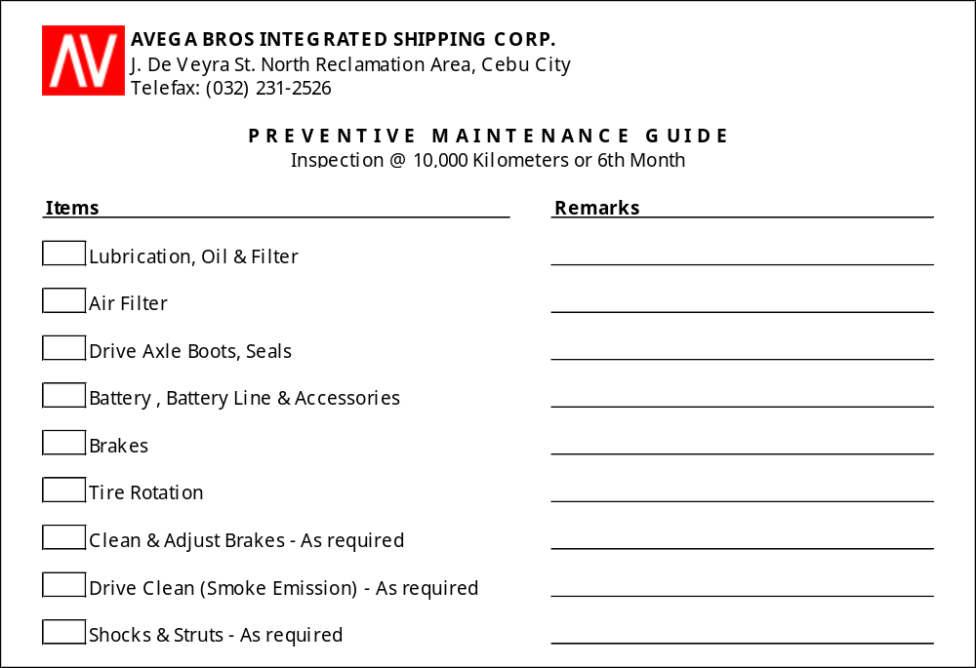

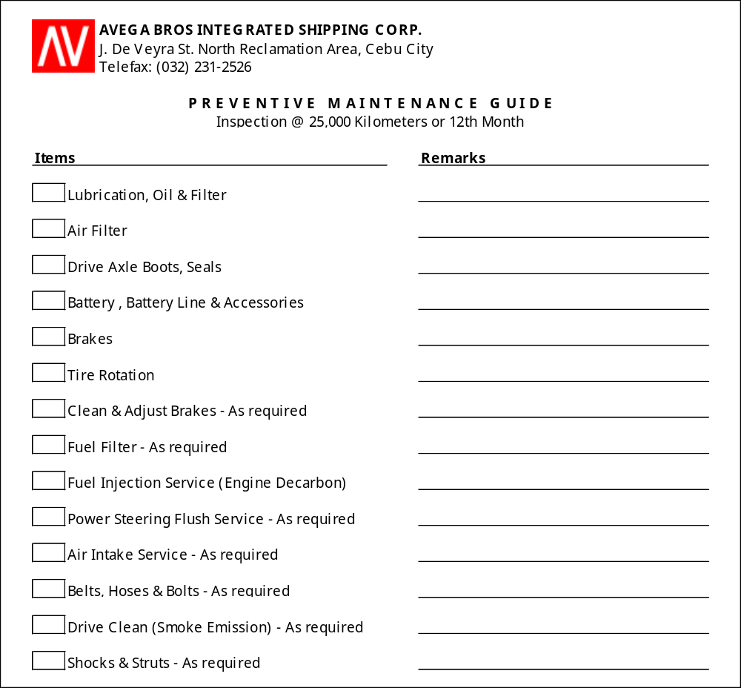

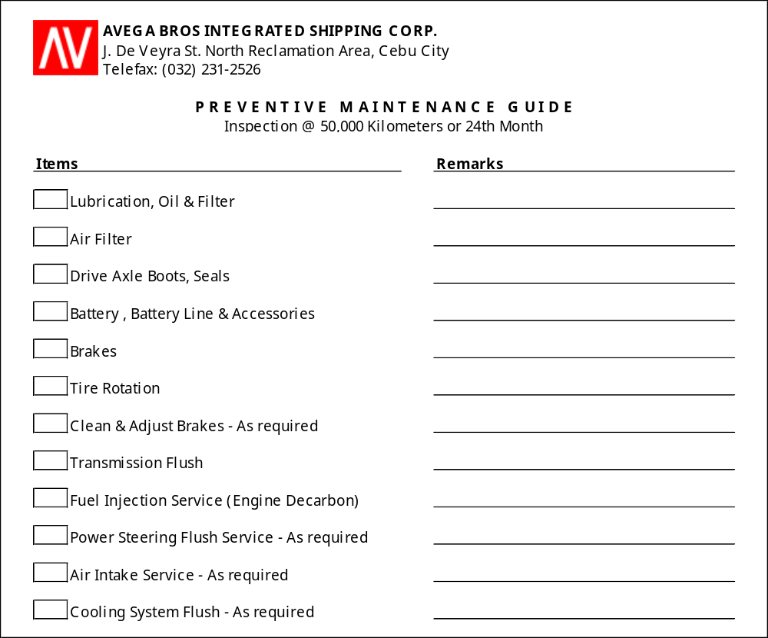

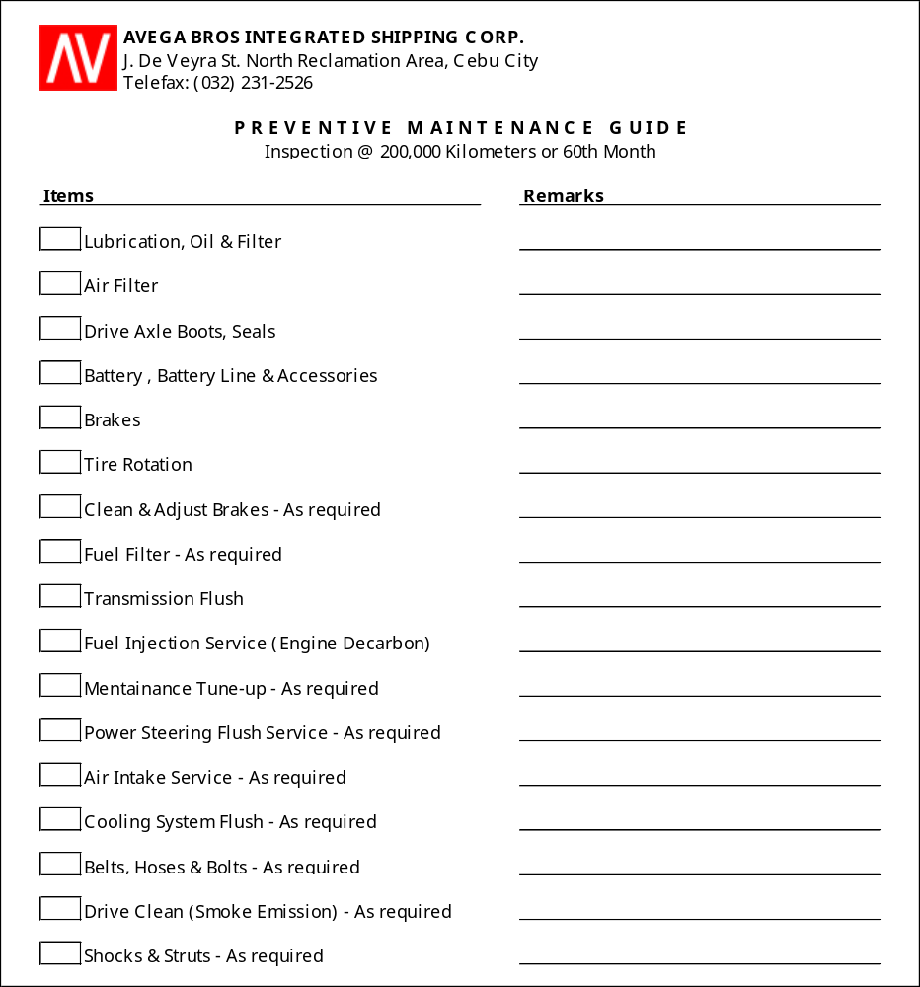

ANNEX B
TIRE REPLACEMENT PROCEDURES

  - Find a safe location
Upon noticing a flat tire, an abrupt brake or turn is to be AVOIDED. Slowly reduce speed and scan surroundings for a level, straight stretch of road with a wide shoulder. Level ground is good to prevent the truck from rolling. Also, straight stretches of road are better than curves because of high chances of oncoming traffic.

NEVER attempt to change tire on a narrow shoulder near oncoming traffic. Keep moving (slowly) until a safer spot is located. While driving on a flat risks ruining the rim, replacing a rim is better than being hit by an inattentive driver.

  - Inform Motorpool Supervisor of flat tire
The truck driver shall inform the Motorpool Supervisor of flat tire replacement.

  - Update Truck Maintenance Card
The truck driver shall update the truck’s Maintenance Card of the particulars of the flat tire replacement (i.e. date, time, problem encountered, course of action, etc.)

  - Turn on hazard lights
To avoid accident, turn on the hazard lights as soon as the need to pull over arises. This will help other drivers be aware of the truck’s location on the side of the road.

  - Apply parking brake
Once stopped, always use the parking brake when preparing to replace a flat tire. This will minimize the possibility of truck rolling.

  - Apply wheel wedges
Wheel wedges go in front of or behind the tires to further ensure the truck doesn’t roll while fixing the flat tire. If rear tire is being replaced, place these in front of the front tires. If the flat tire is at the front, put the wheel wedges behind the rear tires.

Bricks or large stones will work just as well as “real” wheel wedges. However, it must be made sure that they’re large enough to stop the truck from rolling.

  - Remove the hubcap or wheel cover
If the truck has a hubcap covering the lug nuts, it’s easier to remove the hubcap before lifting the truck with the jack. If the lug nuts are exposed, skip ahead to Step F.

Use the flat end of the lug wrench or appropriate hubcap or wheel cover removing equipment to remove the hubcap.

  - Loosen the lug nuts
Using the lug wrench, turn the lug nuts counterclockwise until the resistance is broken. If necessary, exert force by using the foot or all of the body.

Loosen the lug nuts about ¼ to ½ of a turn, but don’t remove them completely yet. Save that for when it’s time to remove the tire/wheel from the truck.

  - Place the jack under the truck
The right place for the jack is usually beneath the vehicle frame alongside the tire that’s flat. The truck’s manual must be consulted to find the proper place to position the jack.

  - Raise the vehicle with the jack
To prevent the jack from settling under the weight of the truck and coming off balance, place a small cut of 2x6” wood beneath it before attempting to raise the truck. This tactic is especially helpful on asphalt.

With the jack properly positioned, raise the truck until the flat tire is about six inches above the ground.

NEVER put any part of your body under the vehicle during or after raising the vehicle with the jack.

During lifting, make sure that the truck is stable. If there are instances of instability, lower the jack and fix the problem before fully lifting the car.

If the jack is lifting at an angle or leaning, lower and reposition it so that it can lift straight up.

  - Unscrew the lug nuts
Remove the lug nuts all the way.

  - Remove the flat tire
Gripping the tire by the treads, pull it gently toward you until it’s completely free from the hub behind it. Set it on its side so that it doesn’t roll away.

  - Mount the spare tire on the lug bolts
Place the spare on the hub by lining up the rim with the lug bolts. Push gently until the log bolts show through the rim.

  - Tighten the lug bolts by hand
Put the lug nuts back on the lug bolts and tighten them all the way by hand. Once they are all on, check each once again, tightening as much as possible. These will be tightened with the wrench after lowering the vehicle to the ground.

  - Lower the truck and tighten the lug nuts
Use the jack to lower the truck so that the spare tire is resting on the ground but the full weight of the truck isn’t fully on the tire. At this point, tighten the lug nuts with the wrench, turning clockwise, as much as possible. Push down on the lug wrench with the full weight of your body.

  - Lower the truck completely
Bring the truck all the way to the ground and remove the jack. Give the lug nuts another pull with the wrench to ensure they’re as tight as possible.

  - Replace the hubcap
If the hubcap which was taken out from the flat tire will fit the spare, put it in place the same way as it was removed initially. If it doesn’t fit, store it away with the tire where the truck equipment is kept.

  - Clean the area where replacement was made
DO NOT forget to put all the tools, equipment and spare parts into the truck’s storage before driving away.

  - Check the pressure in the spare tire
The tire pressure of the spare tire should be checked to make sure that it is safe to drive on. If the tire needs pressure, drive (slowly) to a service station immediately.

  - Take flat tire to the Motorpool Technician
Drive cautiously until arrival at the Motorpool. The technician should be able to determine whether the tire needs a repair or for replacement.

